Math Assignment 1

Godfrey Ouma
University of the People
MATH 1302 - Discrete Mathematics
Saurabh Kumar
February 7, 2024

Math Assignment Unit 1
Based on the concepts of sets, basic operations on sets, Venn diagrams, and set identities that you learned this week, answer the following questions:
1. If A is the set of people who got jobs in the IT sector and B is the set of people who got jobs. Describe the people in each of the following sets:
(a) A ∩ B
These are the people who got jobs in both the IT sector and in any other sector (including IT). They are the common group among people who secured IT jobs and people who got any job.
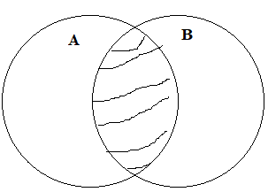
(b) A ∪ B
This set includes everyone who got a job in the IT sector OR got any other job (or both). It consists of all people who got any job at all, regardless of whether it was in IT or not.
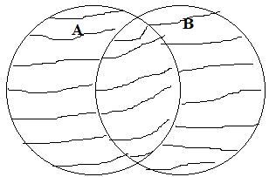
(c) A – B
This set represents the people who got jobs in the IT sector but did not get any job in other sectors. They are specifically those who secured IT jobs but missed out on other opportunities.
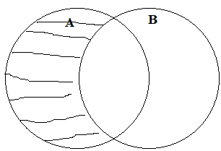
(d) B − A
This set comprises the people who got jobs in other sectors but did not get jobs in the IT sector. They represent individuals who found employment outside the IT field.
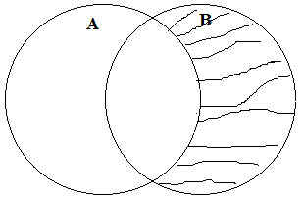
2. Suppose that A is the set of people living in the USA and B is the set of people having a house in Canada. Express each of the following sets in terms of A and B using set operations:
(a) the set of people living in the USA and having a house in Canada
A ∩ B
(b) the set of people living in the USA who are not having a house in Canada
A - B
(c) the set of people who either live in the USA or have a house in Canada
A ∪ B
(d) the set of people who are either non-US residents or do not own a house in Canada.
$\overline{A}∪ \overline{B}$
3. An IT company offered two benefits for the employees. 750 of the employees take the privilege of cabs. 900 of them take breakfast privilege. If 530 employees take both benefits, how many employees work in the company if there are 60 employees who do not take any benefits? Which concept do you use to calculate the number of employees in the company? You can either use a Venn diagram or you can use the principle of inclusion and exclusion.
Representing the scenario using a Venn diagram:
Employees with cabs: $n(A)=750$
Employees taking breakfast: $n(B)=900$
Employees with cabs and taking breakfast: $n(A ∩ B)=530$
Employees who do not take any benefits: $n(ε)=60$
Employees with cabs only: n(A)- $n(A ∩ B)=$750-530=220
Employees taking breakfast only: n(A)- $n(A ∩ B)=$900-530=370
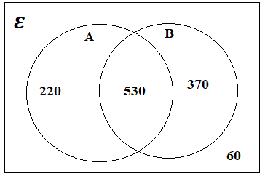
Total number of employees $= n(A)+n(B)+ n\left(A ∩ B\right)+ n\left(ε\right)$
$$=220+370+530+60=1180$$
Concept applied:
The concept used to calculate the total number of employees in the company is the principle of inclusion/exclusion, which refers to the process of adding in, then taking out, then adding back in, and so on (Levin, 2021). To determine the number of employees taking breakfast only, the formula used was $n(A)- n(A ∩ B)=900-530=370$. On the hand, to get the number of employees with cabs only, the formula used was $n(A)- n(A ∩ B)=750-530=220$. To get the number of employees. Finally, to get the total number of employees, the formula used was $n(A)+n(B)+ n\left(A ∩ B\right)+ n\left(ε\right)$. In the end, the whole process of obtaining the total number of employees entailed addition and subtraction of numbers of elements from different sets, thus showing evidence of applying the principle of inclusion/exclusion.

Reference
Levin, O. (2021). Discrete mathematics: An open introduction (3rd ed.). licensed under CC 4.0

